Image Filters Web Application

Pranav Patil 21101B0051

Nirmiti Rane 21101B0073

Aniket Mahajan 21101B0059

Overview:

The Image Processing Web App is a sophisticated web-based application designed to offer users a comprehensive platform for performing advanced image processing tasks. Leveraging cutting-edge technologies and intuitive user interface design, the app empowers users to upload, process, and analyze images with ease. From basic operations like Gaussian Blur to more complex techniques such as Sobel and Prewitt Edge Detection, the app provides a seamless experience for users to explore and experiment with various image processing algorithms.

Features:

1. Advanced Filters: The app offers a diverse range of image processing filters, including Gaussian Blur, Sobel Edge Detection, Prewitt Edge Detection, and Median Filter. Each filter is meticulously implemented to ensure optimal performance and accuracy in processing images.
2. Real-time Processing: Thanks to its robust architecture and efficient algorithms, the app performs image processing tasks in real-time, allowing users to see immediate results as they adjust parameters or apply different filters.
3. Customizable Parameters: Users have the flexibility to customize parameters for each filter, enabling them to fine-tune the processing effects according to their preferences or specific requirements.
4. Image Comparison: The app facilitates side-by-side comparison of the original and processed images, enabling users to visually assess the impact of different filters and adjustments on the image content.
5. Responsive Design: Built with responsive design principles, the app ensures seamless user experience across various devices and screen sizes, making it accessible to a wide audience.
6. Interactive User Interface: The user interface is designed to be intuitive and user-friendly, with clear navigation and interactive elements that guide users through the image processing workflow effortlessly.
7. Error Handling: The app incorporates robust error handling mechanisms to gracefully handle unexpected scenarios, providing informative feedback to users in case of errors or invalid input.

Technologies Used:

* Frontend Framework: React.js is utilized as the front-end framework for building the user interface components and managing the application state efficiently.
* Styling: CSS (Cascading Style Sheets) is employed for styling the user interface elements, ensuring a visually appealing and cohesive design aesthetic.
* Image Processing Algorithms: JavaScript is used to implement image processing algorithms, leveraging the power of modern web browsers to perform complex computations directly within the browser environment.
* File Handling: HTML's input element with type "file" is utilized for handling image uploads, allowing users to select images from their local file system.
* State Management: React Hooks (useState) are employed for managing component-level state within functional components, facilitating seamless interaction and data flow within the application.

Purpose:

The Image Processing Web App serves as a versatile tool for a wide range of users, including students, researchers, photographers, and professionals working in fields such as computer vision, digital image processing, and graphic design. Whether used for educational purposes, experimentation, or practical image enhancement tasks, the app offers a powerful yet accessible platform for exploring the fascinating world of image processing algorithms and techniques. By democratizing access to advanced image processing capabilities through a user-friendly web interface, the app empowers users to unleash their creativity and achieve stunning visual results with ease.

* Implementation Link: <https://github.com/Aniike-t/Image-Processsing-Filters>

Result:

1. Sobel Edge Detection

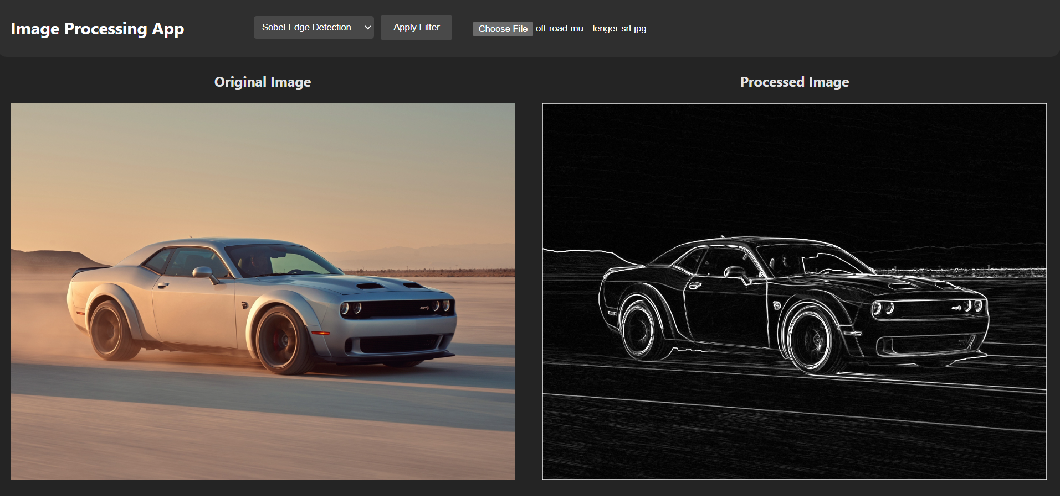

1. Prewitt Edge Detection

1. Median Filter

1. Gaussian Blur

